Product Inventory Management System

SUBMITED BY:
Project Title : Product Inventory Management
Team Id : SWTID-2026-8072
Team Size : 4
Team Leader: S.ARTHI & arthi01102006@gmail.com
Team member: A.K.KOKILAVANI & kokianbu25@gmail.com
Team member: M.JANANI & jananimurugan0808@gmail.com
Team member: M.ABINAYA & abinayaabi31559@gmail.com

PROJECT OVERVIEW:
A Product Inventory Management System is a software application used to manage and track products in a store or business. It helps to keep records of products, stock levels, sales, and purchases in an organized way

INTRODUCTION
The Product Inventory Management System is designed to store and manage information about products available in a shop or warehouse. It helps the business owner easily monitor stock availability, add new products, update product details, and remove products when necessary.

KEY OBJECTIVES

MANAGE PRODUCT INFORMATION:
To store and maintain details of all products such as product ID, name, price, and quantity.
- TRACK STOCK LEVELS:
To monitor the available stock of each product and update it when items are added or sold.
- REDUCE MANUAL ERRORS:
To minimize mistakes that occur in manual record keeping by using a computerized system.
- IMPROVE INVENTORY CONTROL:
To help businesses maintain proper stock levels and avoid overstocking or stock shortages.
- PROVIDE QUICK ACCESS TO DATA:
To allow users to quickly view, search, and update product details whenever needed.
- GENERATE REPORTS:
To provide reports about product availability, stock status, and inventory updates.
- INCREASE EFFICIENCY:
To save time and improve the overall efficiency of managing products in a store or warehouse.

PROJECT INSTRUCTION:

- UNDERSTAND THE PROJECT REQUIREMENTS:
Clearly understand the purpose of the Product Inventory Management System. The system should help manage product details and stock information.

- PLAN THE SYSTEM DESIGN:
Decide the structure of the system, including modules such as product management, stock management, and report generation.

- CREATE THE DATABASE:
Design a database to store product information such as product ID, product name, category, price, quantity, and supplier details.

- DEVELOP THE APPLICATION:
Build the system using a programming language and database (for example: Java, Python, or web technologies with MySQL). Create forms to add, update, delete, and view product details.

- IMPLEMENT KEY FEATURES:
Add new products
Update product details
Delete products
View product list
Track stock levels

- TEST THE SYSTEM:
Check if all functions work correctly. Test adding, updating, deleting, and displaying products to ensure the system works without errors.

- PREPARE DOCUMENTATION:
Write a project report explaining the objectives, system design, modules, screenshots, and results.

- PRESENT THE PROJECT:
Demonstrate the working of the system and explain how it helps manage inventory efficiency.

FEATURES
- PRODUCT MANAGEMENT:
Allows users to add, update, delete, and view product details such as product name, ID, category, and price.
- STOCK MANAGEMENT:
Tracks the quantity of products available in the inventory and updates stock automatically when items are added or sold.
- SUPPLIER MANAGEMENT:
Stores and manages supplier information such as supplier name, contact details, and supplied products.
- ORDER MANAGEMENT:
Handles purchase orders and sales orders to manage incoming and outgoing products.
- INVENTORY TRACKING:
Monitors product movement in real time to avoid stock shortages or overstocking.
- LOW STOCK ALERT:
Sends notifications or alerts when product quantity reaches the minimum level.
- REPORT GENERATION:
Generates reports such as stock reports, sales reports, and inventory summaries.
- USER MANAGEMENT:
Allows admin to create and manage users and assign roles or permissions

PROJECT ARCHITECTURE
High-level architecture diagram illustrating the three-tier backend structure.
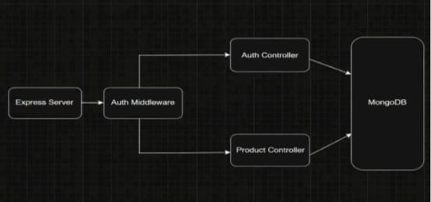

- NODE.JS + EXPRESS BACKEND
- RESTful API architecture
- JWT authentication middleware
- MVC pattern (Models, Controllers, Routes)
- Input validation and error handling

- MONGODB DATABASE
- Document-based NoSQL storage
- Mongoose ODM for schema modeling
- Two collections: Users and Contacts
- Indexed fields for optimized queries

- TECHNICAL ARCHITECTURE

BACKEND ARCHITECTURE (NODE.JS + EXPRESS)
- Controllers: Handle authentication and product logic
- Models: Define database schema
- Routes: API endpoints for authentication and products
- Middleware: JWT verification and error handling
- Configuration: Environment variables and database connection

DATABASE ARCHITECTURE (MONGODB)

USERS COLLECTION:
  - _id
  - name
  - email
  - password (hashed)
  - timestamps
PRODUCTS COLLECTION:
  - _id
  - userId (reference to user)
  - name
  - price
  - quantity
  - description
  - timestamps
RELATIONSHIP:
- One User → Many Products
INDEXES:
- email (unique)
- user Id
- product name
ER DIAGRAM
ER diagram showing User → Product relationship:

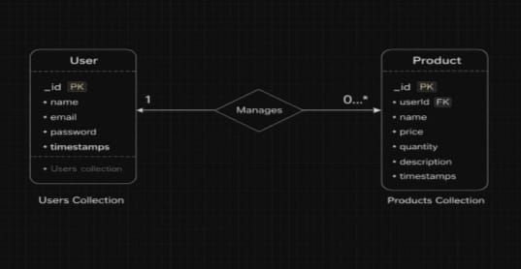

PROJECT SET UP AND CONFIGURATION:

FOLDER STRUCTURE:
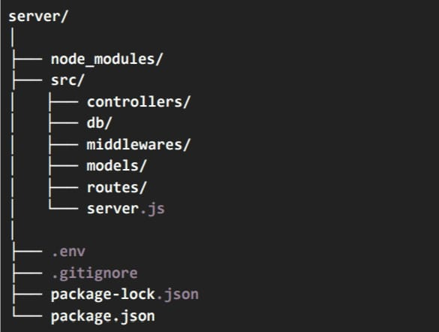

NODE.JS BACKEND PROJECT STRUCTURE EXPLANATION

SERVER/
This is the main root folder of the backend project.
All server-related files and folders are stored inside this directory. It contains the source code, configuration files, and dependencies required to run the backend application.

NODE_MODULES/
This folder contains all the installed npm packages (dependencies) required for the project.
Examples of packages:
Express
Mongoose
Dotenv

This folder is automatically created when running:
npm install
It is usually not uploaded to github, because it can be recreated using package.json

- src/
src stands for Source Code.
This folder contains the main application code.
The project logic is organized into different folders inside src to keep the code clean and maintainable.

SRC FOLDER EXPLANATION

CONTROLLERS/
Controllers contain the business logic of the application.
When a request comes from the client, the controller processes the request and sends a response.
Examples:
- User login logic
- Register user
- Fetch data from database
- Update or delete data
Example controller files:
- userController.js
- productController.js

DB/
This folder contains the database connection code.
It is responsible for connecting the application to the database.
Example files:
- db.js
- connection.js
Example databases used:
- MongoDB
- MySQL
- PostgreSQL
Example code:
mongoose.connect(process.env.DB_URL)

- MIDDLEWARES/

Middlewares are functions that run between the request and the controller.
They are used for performing checks before executing the main logic.
Common uses:
- Authentication verification
- Error handling
- Request logging
- Token validation
Example files:
- authMiddleware.js
- errorMiddleware.js
Example:
If a user tries to access a protected route without logging in, the middleware will block the request.

MODELS/
Models define the structure of the data stored in the database.
They represent database tables or collections.
Example model files:
- User.js
- Product.js
- Order.js

Example fields inside a model:
name: String
email: String
password: String
In simple terms:
Model = Database schema or data structure

ROUTES/
Routes define the API endpoints of the application.
They specify which controller function should run when a specific request is received.
Example route files:
- userRoutes.js
- productRoutes.js
Example API endpoints:
POST /login
GET /users
DELETE /product/:id

SERVER.JS
This is the main entry point of the backend application.
It is responsible for:
- Creating the Express server
- Connecting middleware
- Registering routes
- Starting the server
Example:
const express = require("express")
const app = express()
app.listen(5000)
This file starts the backend server.

.ENV
This file stores environment variables.
Sensitive information such as database URLs or secret keys are stored here.
Example:
PORT=5000
DB_URL=mongodb://localhost:27017/project
JWT_SECRET=secretkey
This file is not shared publicly for security reasons.

.GITIGNORE
This file tells Git which files or folders should not be uploaded to GitHub.
Example:
node_modules
.env
This prevents unnecessary or sensitive files from being pushed to the repository.

PACKAGE.JSON
This is the main configuration file for the Node.js project.
It contains:
- Project information
- Dependencies
- Scripts
- Version details
Example dependencies:
express
mongoose
cors
dotenv

Example scripts:
npm start
npm run dev

PACKAGE-LOCK.JSON
This file locks the exact versions of installed dependencies.
It ensures that when someone installs the project, the same versions of packages are installed.
This helps maintain project stability.

PROJECT EXECUTION

- EXECUTION STEPS
1. Open terminal in server folder.
2. Make sure you have a start script in the package.js file
3. Run:
npm start

- CONSOLE SHOULD DISPLAY:
Server running on PORT
Database Connected

- API TESTING :
Use Thunder Client to test APIs: TEST APIs
REGISTER USER:
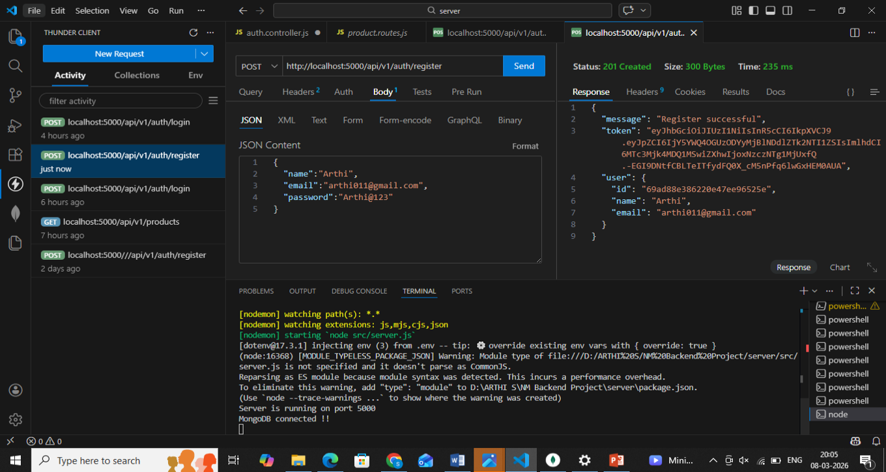
LOGIN USER:
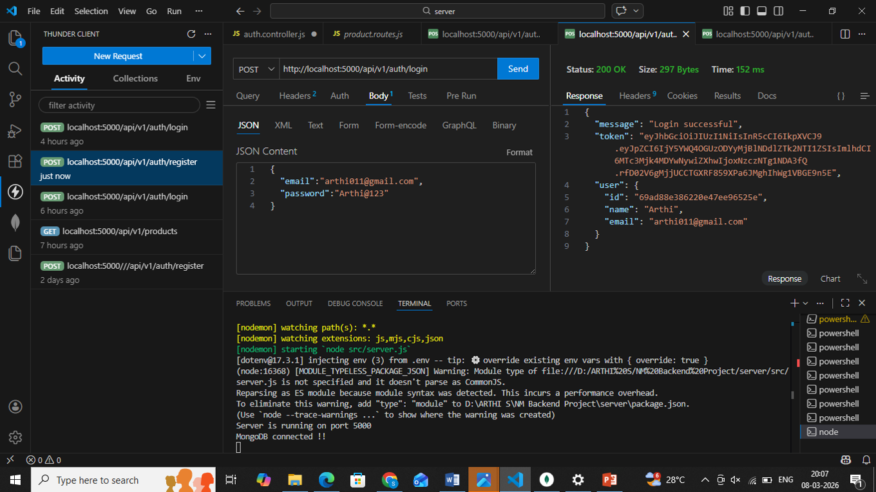

CREATE PRODUCT:
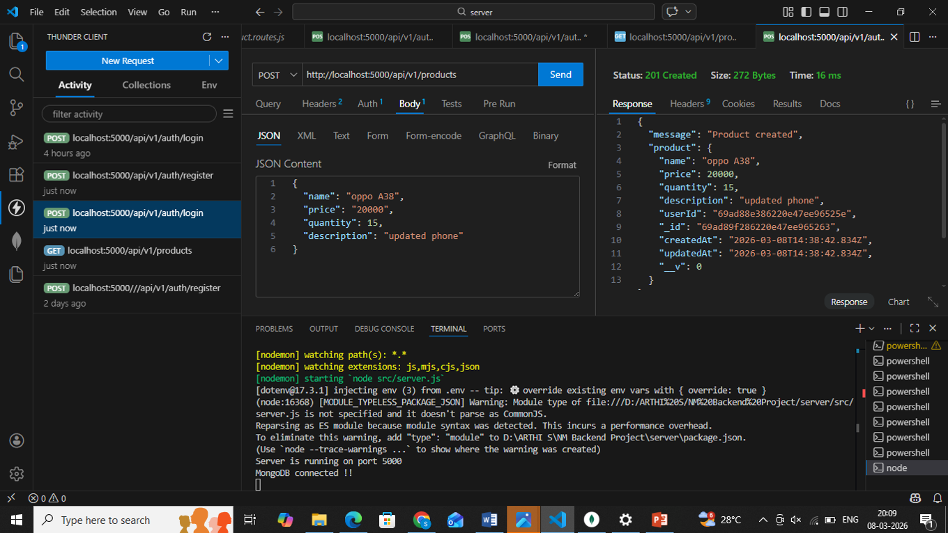

GET ALL PRODUCTS:
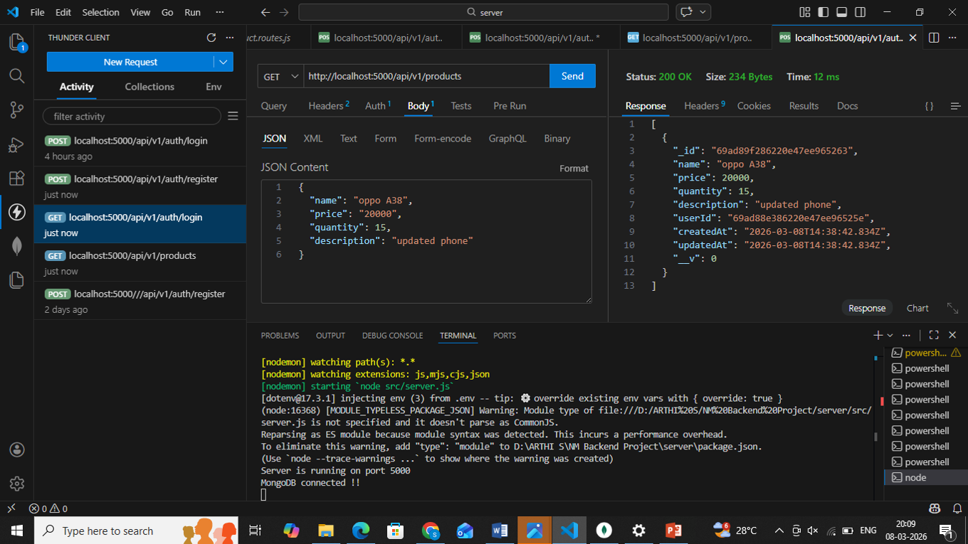

UPDATE PRODUCTS:
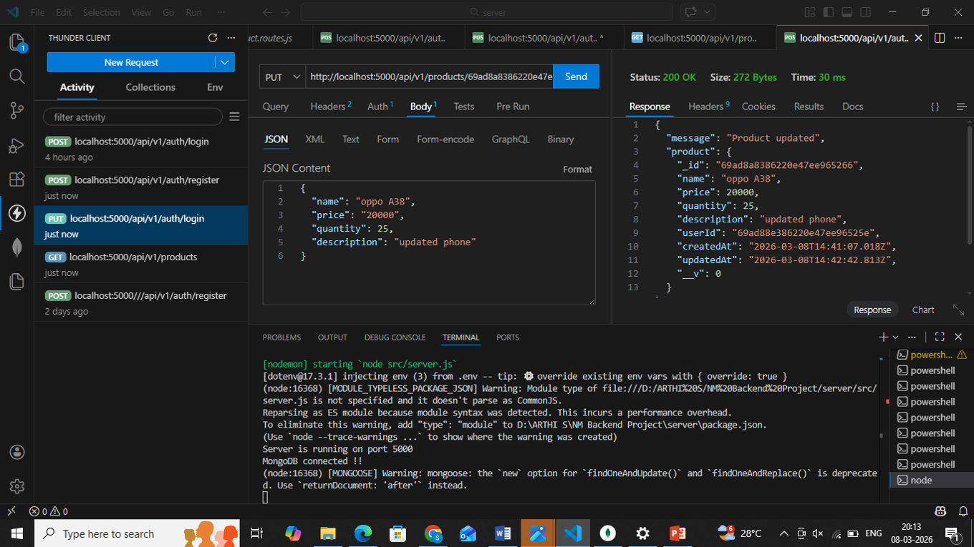

DELETE PRODUCTS:
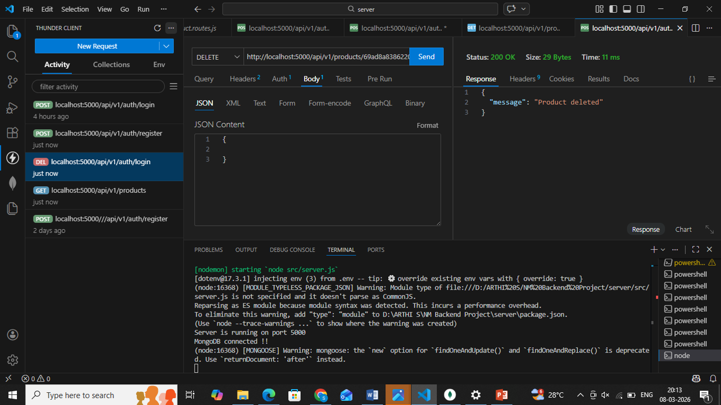

PROJECT DOCUMENT:
https://drive.google.com/drive/folders/14VJJfB7tmWdc_44r1UkC7TybOB776V34?usp=drive_link

PROJECT DEMO VIDEO:
https://drive.google.com/file/d/16hTpaOkiTvnL1oYFxNUEwEBaqzywshQf/view?usp=drivesdk

GITHUB LINK:
https://github.com/Arthisuresh2006/PRODUCT-INVENTORY-MANAGEMENT.git

CONCLUSION:
The Product Inventory Management System helps businesses manage and track product details efficiently. It allows users to add, update, delete, and view product information easily. This system reduces manual work, minimizes errors, and improves inventory control. Overall, it makes product management faster, more accurate, and more organized.

THANK YOU

